Timothy Schindler

Final Project

My final project is a ranking system based off the game Overwatch, a team-based, FPS Shooter. It takes the statistics from the user and then updated the number that represents their skill rank. It also updates the user’s rank if they enter a higher rank or drops out of the rank that they are in.

The main motivation was to create a system that could be implemented into a video game. I would like to work on video games, but I do not see myself working on the creative part of video game creation. But I would like to be part of the programming of the game and other systems that could be used in the game. I chose to based the system off the game Overwatch because it is one of my favorite video games and I wanted to see if I could find something to add or to improve it.

The system takes in the information given by the user and uses preset averages to determine the change in rank. The user enters the information that is required and they has to press the button that returns the new rank score.

Performance

+player : Player

+win : Boolean

+kills : int

+objKills : int

+objTime : int

+damage : int

+healing : int

+deaths : int

Performance(plyr : Player, kills : int, objKills : int, objTime : int, damage : int, healing : int, death : int)

Performance()

setWin(win : Boolean) : void

getPlayer() : Player

getWin(): Boolean

getKills() : int

getObjKills() : int

getObjTime() : int

getDamage() : int

getHealing() : int

getDeaths() : int

Player

+rank : Rank

+name : String

+SR : int

Player()

Player(name : String, SR : int)

getRank() : Rank

getName() : String

getSR() : int

setRank(rank : Rank) : void

setSR(SR : int) : void

getNewSR(performance : Performance) : void

didUpdate() : void

Rank

+name : String

+avgKills : double

+avgObjKills : double

+avgObjTime : double

+avgDamage : double

+avgHeal : double

+avgDeaths : double

+minSR : int

+maxSR : int

+aboveRank : Rank

+belowRank : Rank

Rank()

Rank(name : String, avgKills : double, avgObjKills : double, avgObjTime : double, avgDamage :

double, avgHeal : double, avgDeaths : double, minSR : int, maxSR : int)

setAboveRank(r : rank) : void

setBelowRank(r : rank) : void

getAboveRank(r : rank) : Rank

getBelowRank(r : rank) : Rank

getMinSR() : int

getMaxSR() : int

getName() : String

getAvgKills() : double

getAvgObjKills() : double

getAvgObjTime() : double

getAverageDamage() : double

getAvgHeal() : double

getAvgDeath() : double

Overwatch is the only game that I have played that has an actual Rank system that works so I did not have other systems to really think about. I played Call of Duty when I was younger but there was never a good competitive system. The system that was used was that everyone started at the same place. So, someone who is not great would get matched up with someone who is good in their first competitive match. This will cause new players to get frustrated and not want to play the game. That’s why competitive games need to start with a more balanced games, so people are willing to play competitive. Like mentioned in my miles stone paper, league of legends has a decent competitive system where there are rank up games and placement games.

The specific problem that my system is facing is providing a good experience for players by accurately representing their rank. With the information given by my system people can have more balanced games by putting people on teams with people with similar skill rankings. Another issue that this is facing is the community hate that Blizzard (the company that made Overwatch) is receiving because of how bad the current ranking and competitive system. Overall, the problem I made for myself was if my boss to make a ranking system for the game I am working on.

USER MANUAL

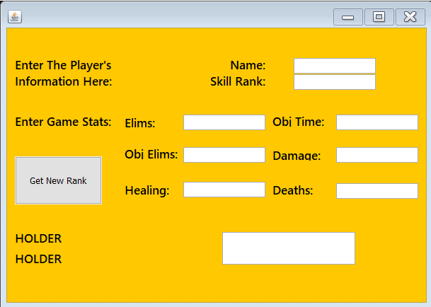

1. Enter your name (String) and rank (Integer)
2. Enter in the statistics (all Integer)
3. Finally click the giant button

When starting my project, I wanted to create a program that ranked players accordingly to their rank. I wanted to create a project that took in information and used it to generate a new SR for the player. And after finishing the project I can say I completed my goals. I created my own mini algorithm to determine the change absolute change in the user’s SR. While working on the program I felt it did not look right just in the console, so I decided to make a GUI. This was the hardest part since I have not done anything with GUIs since sophomore year of high school and that was with Visual Basic. I used Youtube videos to find out how to create and use GUIs. It was not as hard as I thought it was going to be, but I only learned the basics and I still do not feel 100 percent confident with GUIs. Overall, I am happy with how my project came out.

Works Cited

“Call of Duty®.” *Call of Duty®*, www.callofduty.com/.

*League of Legends*, na.leagueoflegends.com/en/.

*Overwatch*, playoverwatch.com/en-us/.

ProgrammingKnowledge. “Java Eclipse GUI Tutorial 2 # Creating A Simple Calculator Using JFrame.” *YouTube*, YouTube, 28 July 2014, www.youtube.com/watch?v=-GoqPrxM8TQ&t=687s.